**Covid-19 myth busters**

Every disease outbreak or pandemic situation carries together several facts and myths related to them. Everyone needs their protection from the disease outbreaks, but it is highly confusing for them to decide what to believe and what not.

Corona pandemic is flooded with various rumors, myths, and facts blended with huge complications and confusions. Garlic stops corona from spreading, corona cannot survive hot and humid weather, pollution increases COVID, and what not! How many of Covid-19 related rumors have approached you? And, how many out of them all are true? Confused? Well, with this blog, we will solve most of the Covid-19 related queries going on.

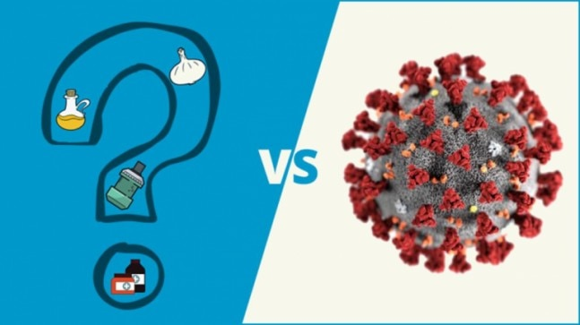

Let us swim deep into this ocean of Corona pandemic and their rumors and identify the myth busters.

* **To avoid Corona, it is necessary to wear masks round the clock.**

 Wearing a mask is only required while going out or interacting with people to avoid coming in contact with the water droplets. Also, during exercises or physical hardships, masks should be avoided to ensure proper air supply for breathing.

* **Alcohol reduces the risk of the Covid-19 virus and cures it soon.**

Alcohol does not reduce any risk and is no treatment for the virus. Instead, there might be serious issues caused due to excessive alcohol consumption like organ failure and addiction.

* **Thermal scanners detect the virus affected patients.**

Thermal scanners only detect temperature. They identify the people with fever, and since one of the corona symptoms as having mild to moderate fever, it might give a warning. But, since there are many reasons for fever, no assumptions regarding them are trustworthy.

* **Covid-19 vaccines and medicines are released by some wise people.**

There is no cure or treatment or vaccine available for corona till now. However, patients with mild to moderate effects are cured by enhancing their immunity with Vitamin C or other immunity boosters. Also, there are some vaccines in the trial even in India over 1,000 volunteers, and if this goes well, by August-15, 2020, vaccines are expected to be released.

* **Pepper and ginger in food can reduce the chances of corona risk.**

Pepper and ginger though enhances the taste of the food, they do not have any effect on the virus. The best way to stay safe is to maintain proper distance with people and wash hands properly after any contact without touching your mouth with your hands. Also, use sanitizer whenever you go out and have any physical contact.

* **UV scanners should be used for disinfecting the body.**

UV scanners should not be used for any bodily contacts as these rays are highly harmful to the skin and the body cells and their exposure might cause severe irritation and even burns.

* **Avoid shipped packages or packaged food to stay safe.**

Corona virus is not carried with shipped packages and packaged food as they go through various levels of disinfection and sanitization. Just make sure that the delivery person or the shop owners are not infected with the virus and sanitize the products before use, and you are good to go.

Eating outside food is safe too until the cook is infected with the virus as food does not cause corona, it is a water-borne disease. Also, exposing to the sun, staying hot, having soda, antibiotics, drinking more water, pneumonia vaccines, being able to hold your breath for 10 seconds, none of the above manages to cure or reduce the pandemic effects. And, flies, mosquitoes, and pet animals do not cause Corona.

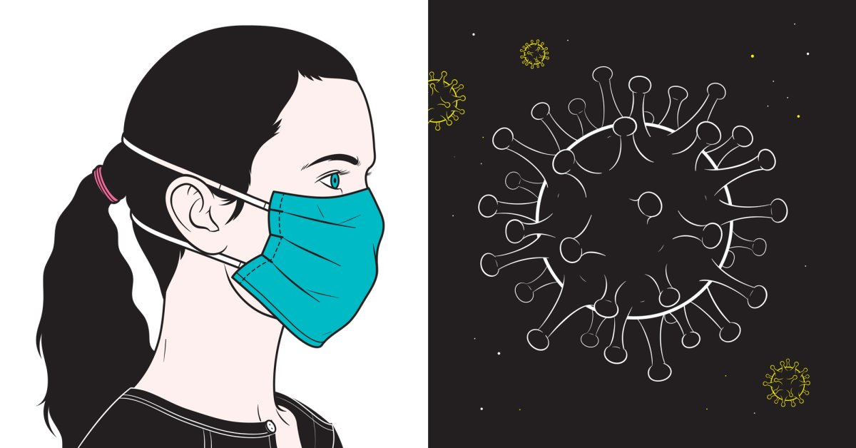

These are a few myth busters related with the Covid-19 pandemic. And, Corona is not prone to any age group or gender specifically; it can be caused to anyone and can be transferred to anybody coming in any age group or gender. The only thing that causes resistance to the virus is good immunity. Also, Corona shows mild or no symptoms in 80% of the infected population. Out of those who are identified with any symptom, many can be cured within 20 to 30 days. Only those with high infections and severe illness caused due to certain reasons are at risk of death. CDC (Center for Disease Control and Prevention) estimated the Infection Fatality Rate (IFR) to be just 0.26%.

Wash hands properly and sanitizes your body and home, and you are good to go!

